**PROJECT DESIGN PHASE-1.**

SOLUTION ARCHITECTURE.

**PROJECT TITLE : IOT based Safety Gadget for Child Safety Monitoring and Notification.**  **Team Id: PNT2022TMID22515**

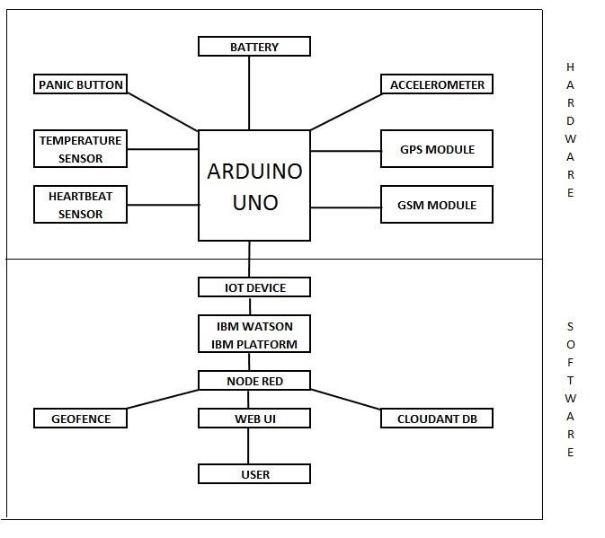**SOUND**

**RECORDER**

**CAMERA**